CYBIT110 Chapter 7 Skills Assessment 2 - Configure Linux Storage

Objective
Be able to format and partition a disk in Terminal and with Disks Utility.

Required VM
- Ubuntu VM

Part 1 Configure A Hard Drive in Linux
In this part, you will use Linux Terminal to format, partition, mount, and unmount a disk.
- Before powering on Ubuntu VM, you will need to add two hard drives.
- Click Edit virtual machine settings.
- In the Hardware tab, click Add.
- Select Hard Disk and click Next.
- In the Disk Type, leave as default (SCIS) and click Next.
- In Select a Disk window, leave as default Create a new virtual disk and click Next.
- In Specify Disk Capacity window, in max size, change value to 10 and click Next.
- In Specify Disk File, leave as default and click Finish.
- Repeat Steps 3-8 to another hard drive, but the size of the second one will be 5 GB.
- In the VM Settings page, click OK.
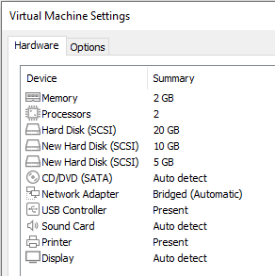
- Power on Ubuntu VM and log in.
- Open Terminal window.
- The fdisk Linux command manages disk partitions in Linux. ﻿Fdisk ﻿(fixed disk or format disk) is a text-based command-line utility for viewing and managing hard disk partitions on Linux. Using fdisk you can view, create, resize, delete, change, copy and move partitions. Fdisk allows you to create a maximum of four primary partitions as permitted by Linux with each requiring a minimum size of 40mb. Linux fdisk does not understand GUID partition tables (GPTs) and is not designed for large partitions.
- To view Linux partition information, type sudo sfdisk -s and press enter. You are prompted for the password. Type P@ssw0rd. You will see partition and disk information with the size of each one in bytes.
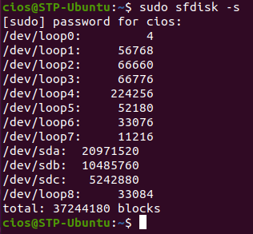
- To list all detected hard disks formatted and unformatted, type the command sudo fdisk -l and press Enter. It will list all of entries in the /dev directory.
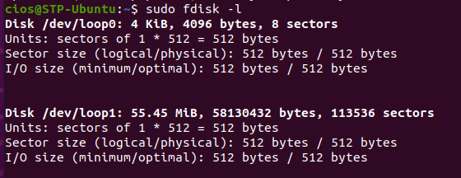
- To filter only sd drives, type the command sudo fdisk -l /dev/sd[a-c] and press Enter.
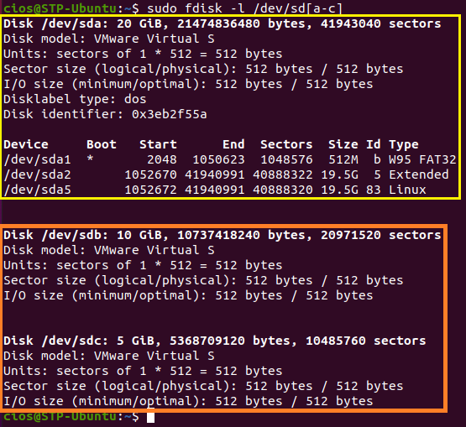
- Insert a screenshot of the result showing all three sd disks.
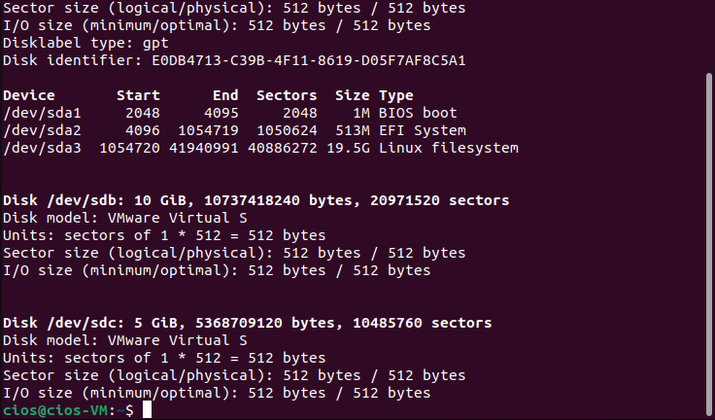
- Notice in the yellow box is the formatted and partitioned hard disk 1 labeled as /dev/sda. In the orange box are the unformatted/non-partitioned hard disks 2 and 3 labeled as /dev/sdb and /dev/sdc.
- The naming scheme is file-based, with file names in the form of /dev/xxyN.
Note: Here is how to decipher the partition naming scheme:
- /dev/ - This is the name of the directory in which all device files reside. Since partitions reside on hard disks, and hard disks are devices, the files representing all possible partitions reside in /dev/.
- xx - The first two letters of the partition name indicate the type of device on which the partition resides, usually either hd (for IDE disks) or sd (for SCSI disks).
- y - This letter indicates which device the partition is on. For example, /dev/hda (the first IDE hard disk) or /dev/sdb (the second SCSI disk).
- N - The final number denotes the partition. The first four (primary or extended) partitions are numbered 1 through 4. Logical partitions start at 5. So, for example, /dev/hda3 is the third primary or extended partition on the first IDE hard disk, and /dev/sdb6 is the second logical partition on the second SCSI hard disk.
- To view partition information on second hard disk, type sudo fdisk -l /dev/sdb and press Enter.
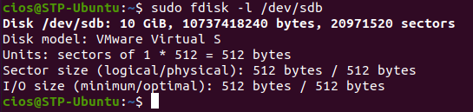
- To partition the second disk /dev/sdb, type sudo fdisk /dev/sdb
Note: This will provide you with a prompt. Enter m to see the list of all available commands of fdisk which can be operated on /dev/sdb.
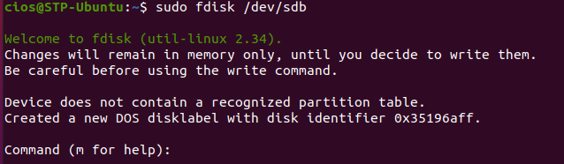
  - The basic fdisk commands you need to create/delete/modify a partition are:
    - m – print help
    - p – print the partition table
    - n – create a new partition
    - d – delete a partition
    - q – quit without saving changes
    - w – write the new partition table and exit
- To create a new disk partition:
  - Enter ‘n’ to create a new partition which will prompt you to specify for either a primary partition or an extended partition.
  - Enter ‘p’ for a primary partition.
  - For the partition number, type 1
  - You will then be prompted to enter the first cylinder or sector number of the partition to be created. Press Enter to accept the defaults.
  - You will then be prompted to enter the Last cylinder or sector number of the partition to be created. Press Enter to use all available space after the first sector. You may enter a specific size such as +2G or +256M for a 2 gigabyte or 256 megabyte partition respectively but not for this assessment.
  - Run ‘w’ command to write the changes
  - You need to reboot the VM, type the command reboot
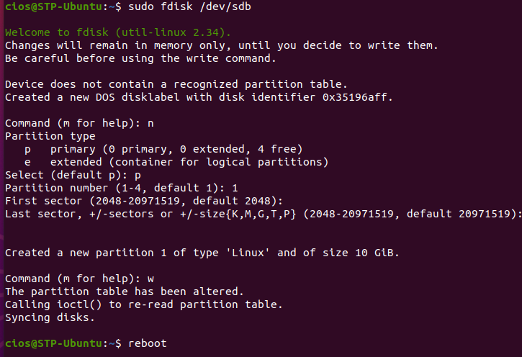
- Return to Terminal window, type the command sudo fdisk -l /dev/sd[a-c] and press Enter. Type your password. The disk should now have a partition named /dev/sdb1.
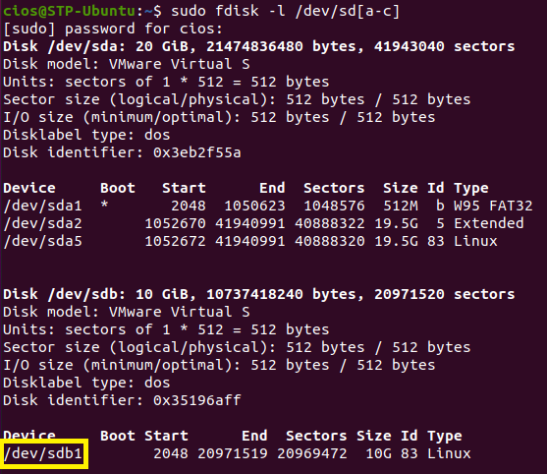
- Insert a screenshot of the result showing the new partition for /deb/sdb.
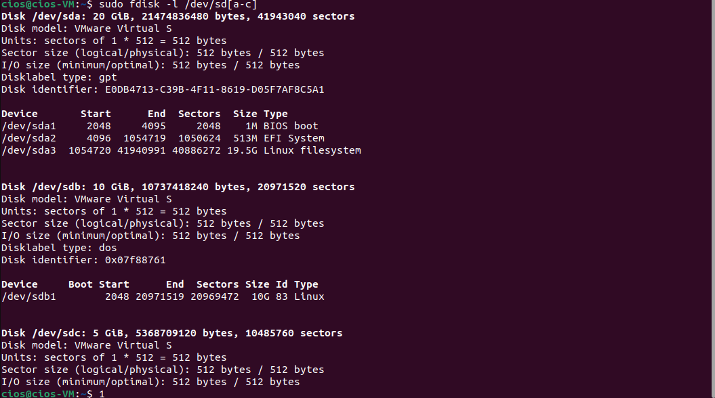
- Ext4 is the current and default file systems for most Linux distros. To format a file system for an external hard drive to work with Windows or macOSx, use exFAT or FAT32.
- The mkfs (i.e., make filesystem) command is used to create a filesystem (i.e., a system for organizing a hierarchy of directories, subdirectories and files) on a formatted storage device or media, usually a partition on a hard disk drive (HDD). The –t option or --type=<type> will specify the filesystem type; when unspecified, ext2 is used
- To format Linux partitions using ext4 on the /dev/sdb1, type the following command: sudo mkfs –t ext4 /dev/sdb1 and press Enter.
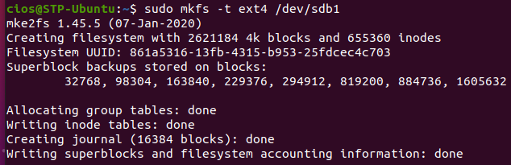
- The /dev/sdb disk needs to be mounted to use it. To create a mount point, first create a mount point /disk1 and use mount command to mount /dev/sdb1, type the following commands and press Enter after each command:
  - sudo mkdir /disk1
  - sudo mount /dev/sdb1 /disk1
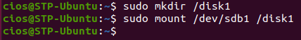
- The lsblk Linux command displays block devices, when used with the -f option, it prints file system type on partitions and its mountpoints. Type the command lsblk -f and press Enter. Notice in yellow, /dev/sdb1 has been configured for ext4 file system and has been mounted on /disk1. The disk now can be used.
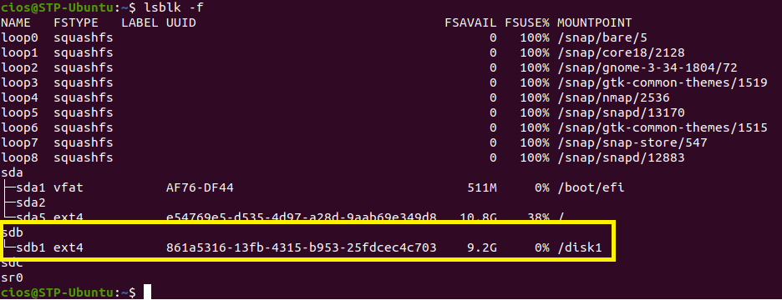
- Insert a screenshot of the result showing /dev/sdb1 content.
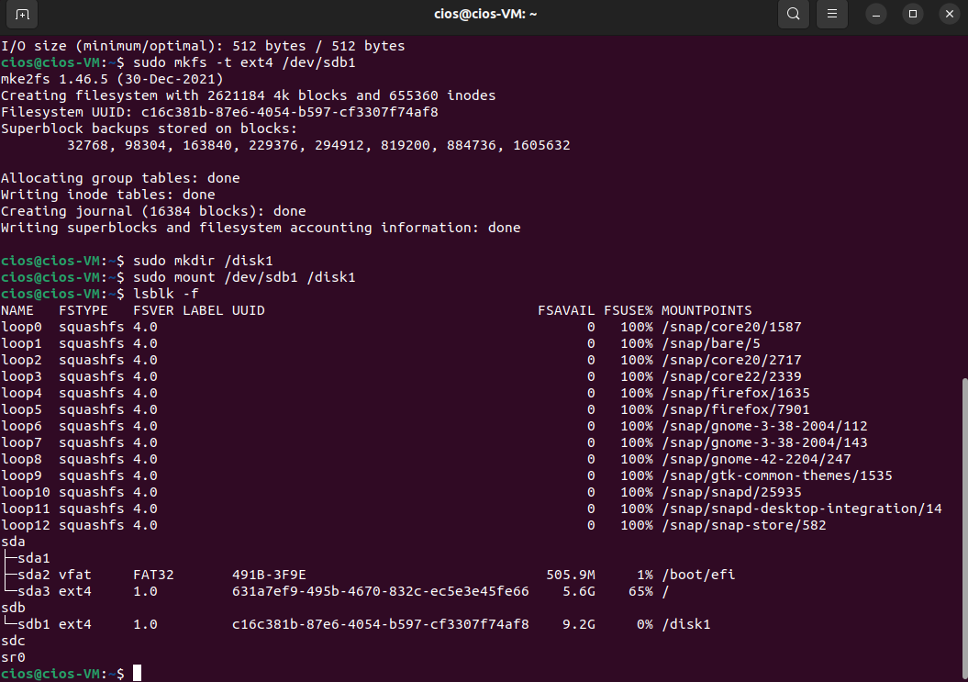
- The df Linux command is primarily intended to report file system disk space usage. It is still a good utility to print out the disks that are available to the system. You can use the -h option with df to print out the disk usage in a human readable format. To view the mount of /dev/sdb1 using the df command, type the command df –h and press enter.
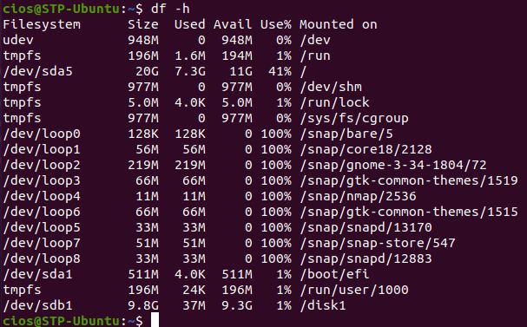
- The umount command is used to unmount any mounted filesystem on your system. Run umount command with disk name or mount point name to unmount currently mounted disk. Type the command sudo umount /dev/sdb1 and press Enter.
- To confirm that /dev/sdb1 is unmounted, type lsblk -f /dev/sdb and press Enter. In the MOUNTPOINT column, /disk1 should not be present.
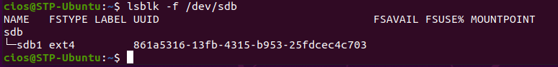
- Insert a screenshot of the result.
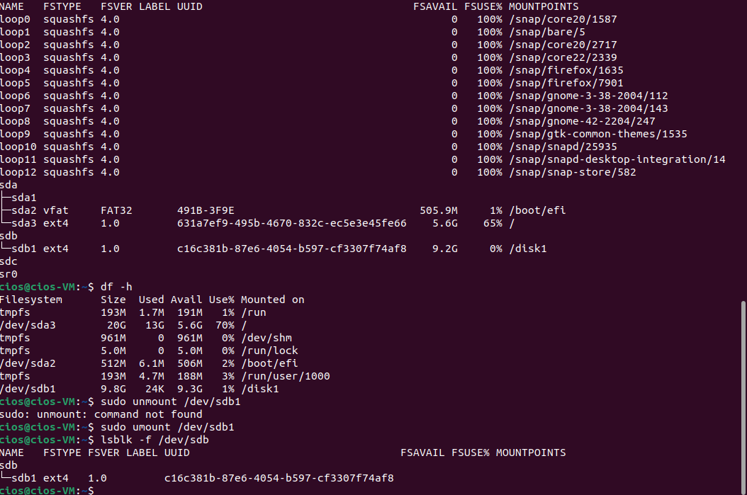
- Mount /dev/sdb1 again with the command sudo mount /dev/sdb1 /disk1
- In Linux, the hard drive partitions are generally not mounted at boot. It can be permanently mounted. You will need /dev/sdb1 UUID. UUID is a unique identifier used in partitions to uniquely identify partitions in Linux operating systems. UUID is a property of the disk partition itself.
- You can use the lsblk -f command to filter just /dev/sdb. Type the command lsblk -f /dev/sdb and press enter. The partition’s UUID is in yellow. 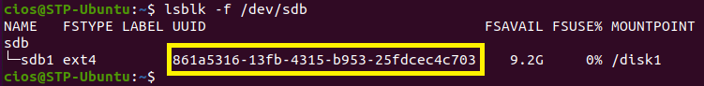
- Record the UUID for /dev/sdb1.
c16c381b-87e6-4054-b597-cf3307f74af8
- To mount the partition permanently, the UUID needs to be entered in /etc/fstab file, type the command: sudo nano /etc/fstab
- One line of code is needed at the end of the file. The format of this line of code is as follows:
UUID=<uuid-of-your-drive> <mount-point> <file-system-type> <option> <dump> <pass>
Here is a breakdown of the syntax:
- Device/UUID – specifies the mount device that are usually device filenames, partition’s labels, or UUIDs
- Mount point – specifies the mount point, the directory where the partition or disk will be mounted
- File system type – specifies the file system type used by the partition
- Options – specifies the mount options. Most file systems support several mount options, which modify how the kernel treats the file system. You may specify multiple mount options, separated by commas. There are many options.
- Backup operation – the fifth field contains a 1 if the dump utility should back up a partition or a 0 if it shouldn’t. This is an outdated utility that should not be used, so use 0 always.
- Pass (File system check order) – specifies the order in which fsck checks the device/partition for errors at boot time. A 0 means that fsck should not check a file system. Higher numbers represent the check order. The root partition should have a value of 1, and all others that need to be checked should have a value of 2.
- Press the down arrow to the first next open line and type the following:
  - #/dev/sdb1 is the 2nd disk for <your name>
  - UUID=uuid-of-your-drive /disk1 ext4 defaults 0 0
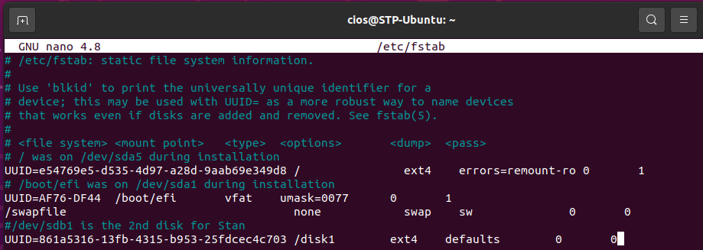
- To save the file, press Ctrl + O and then press Enter to save the file to /etc/fstab
- Press Ctrl + X to exit.
- To verify that two lines were added to /etc/fstab, type the command: sudo cat /etc/fstab and Enter.
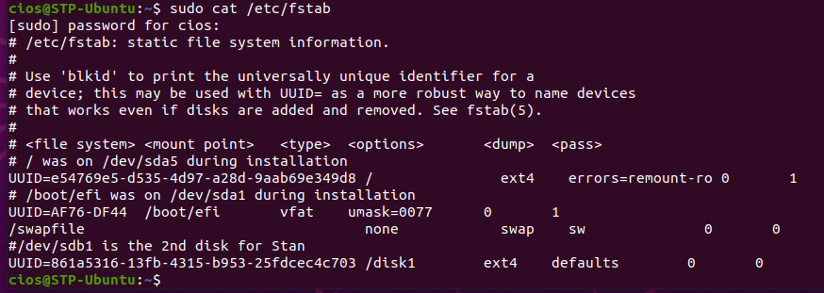
- Insert a screenshot showing the results of the cat /etc/fstab command.
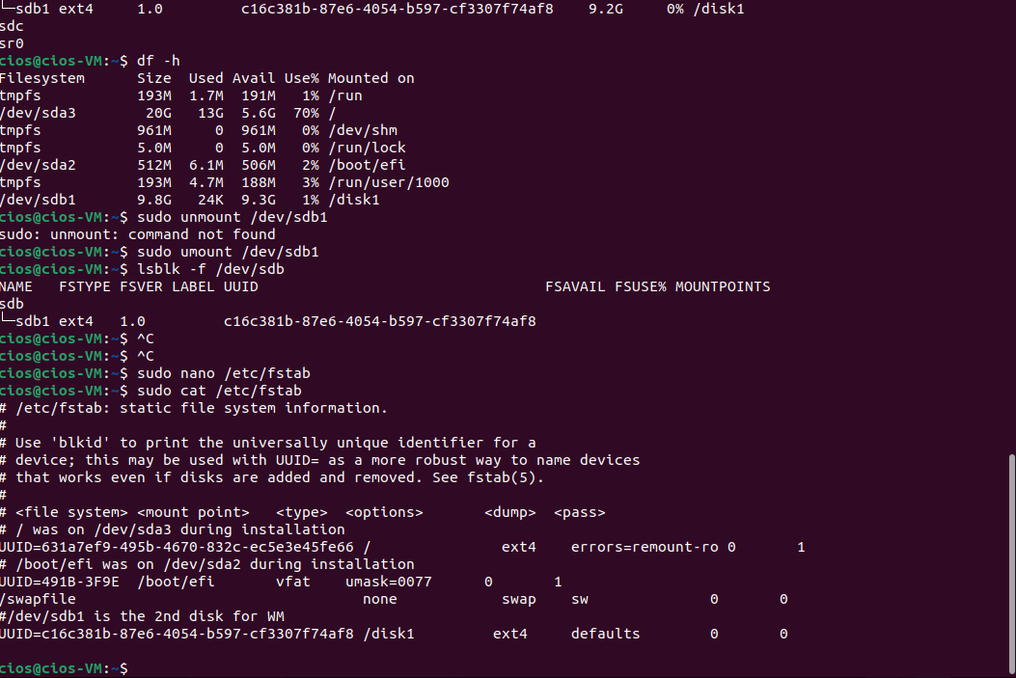
- We always want to test the fstab before rebooting (an incorrect fstab can render a disk unbootable). To test do: sudo mount -a and press Enter. If there is an issue, you will see an error message. If there are no issues, you will see the prompt.
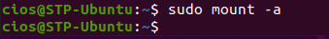
- Reboot the VM with the command reboot and press enter. Log back in.
- To confirm that /dev/sdb1 is permanently mounted, type the command: lsblk -f /dev/sdb and press Enter.
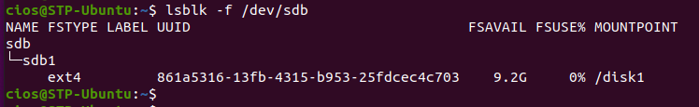
- Insert a screenshot of the result.
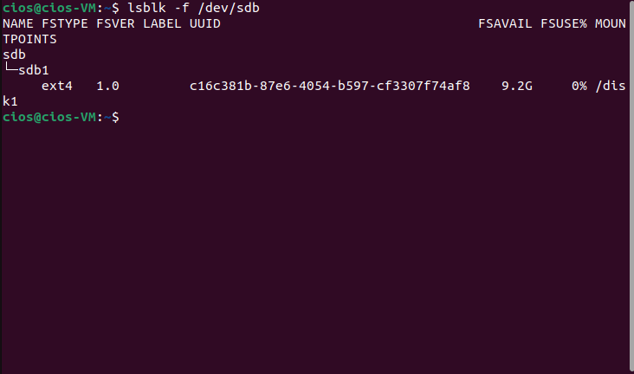
- Close Terminal.

Part 2 Using Disks Utility in Linux
In this part, you use the Disks utility in Linux to work with a newly installed disk.
- In the Dashboard, click Show Applications.
- Click Utilities and then click disks to open the Disks utility.
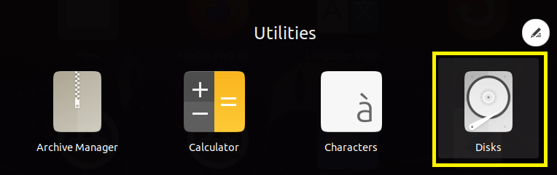
- There are three hard disks (it is running on VMware, so the disks are labeled as VMware disks). If you click on any of the devices from the list, the existing partitions and other information will be displayed. On the first disk, there are two partitions. Click on Partition 5.
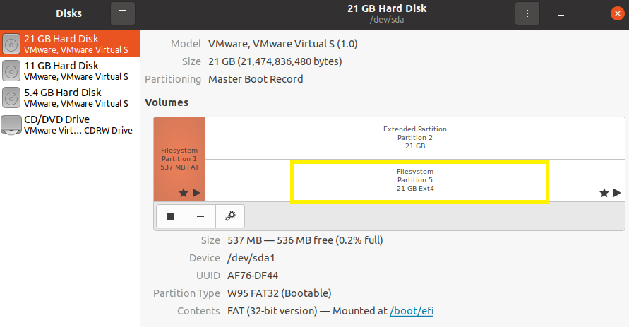
- Notice in Partition 5, you will see the size of the partition, the device name, UUID, partition type, file system, and mounted directory.
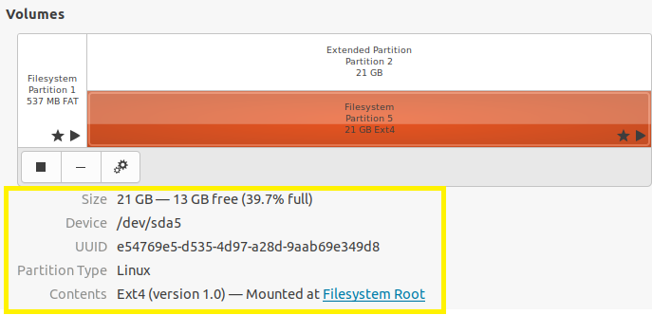
- Click on the second hard disk (11 GB Hard Disk). The content in the disk should be what you did in Part 1.
- Insert a screenshot of the contents of the second hard disk.
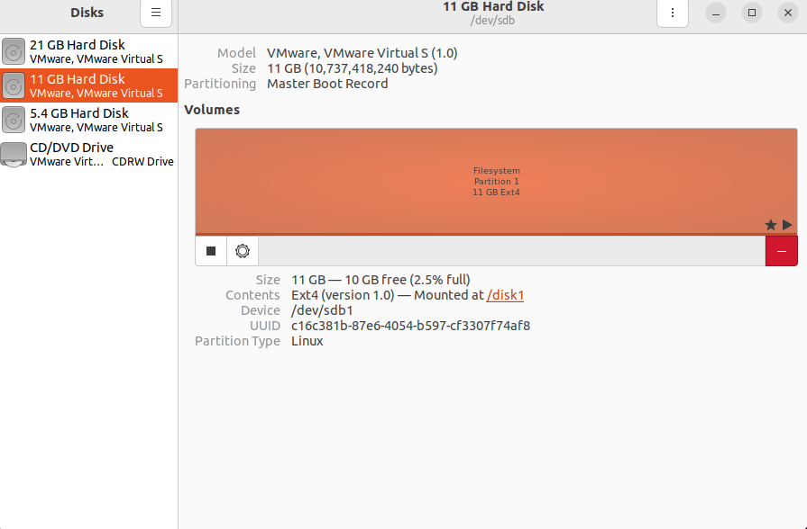
- Click the third disk (5.4 GB Hard Disk) in the left pane. In the right pane, you see that the volume is listed as Unknown.
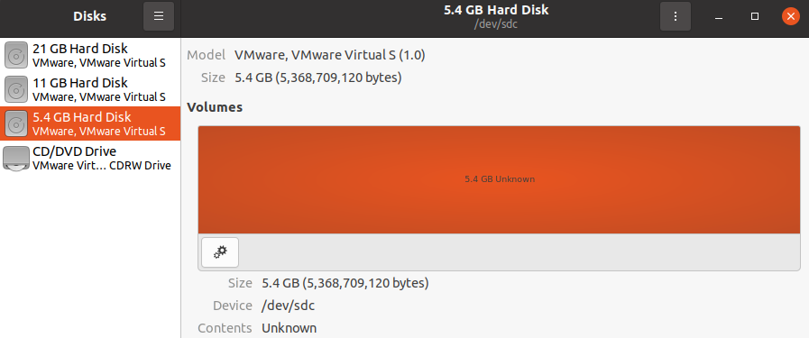
- Click the Additional partition options (the two-sprocket icon) button under the volume and click Format Partition.
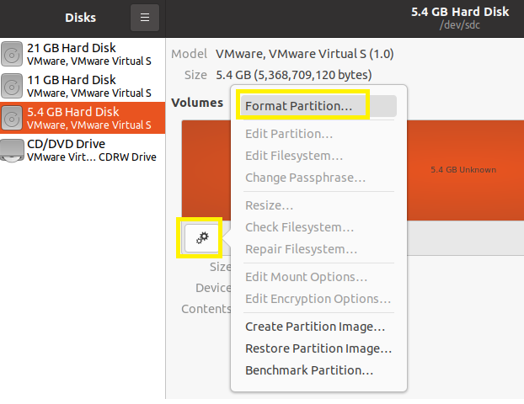
- In the Format Volume dialog box, in the Volume Name test box, type XX-Ch7SA2 (XX will be your initials), accept the default Erase and Type options. Click Next.
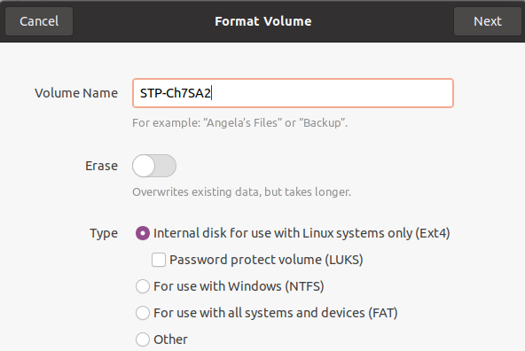
- The next dialog box asks you to confirm the details. Click Format.
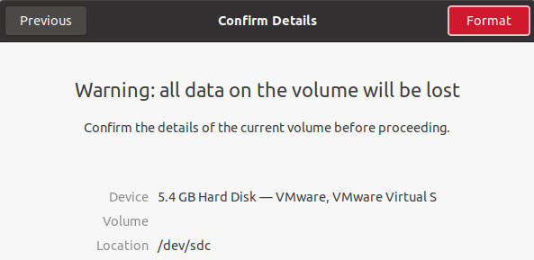
- If you are prompted for your password, type P@ssw0rd and click Authenticate button.
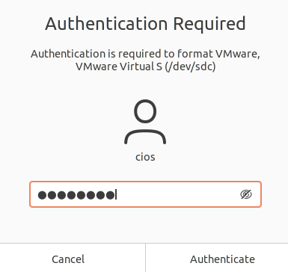
- Click the Mount selected partition arrow under the volume. If you are prompted for your password, enter it and click Authenticate.
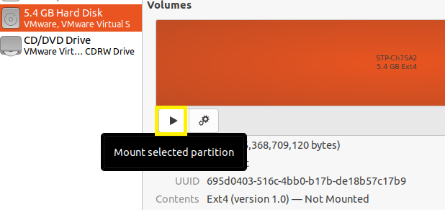
- By default, the volume is mounted in /media/cios/XX-Ch7SA2, where cios is the current user logon name.
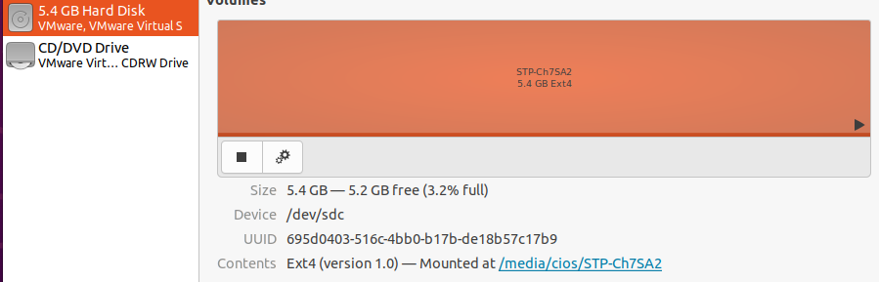
- Click the link next to Mounted at; a Files window opens and shows the volume.
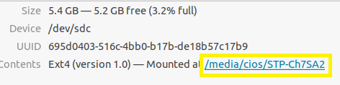
- The new volume is ready to use. Right-click in the right pane of Files. Notice that you can use the new volume like any folder in Linux.
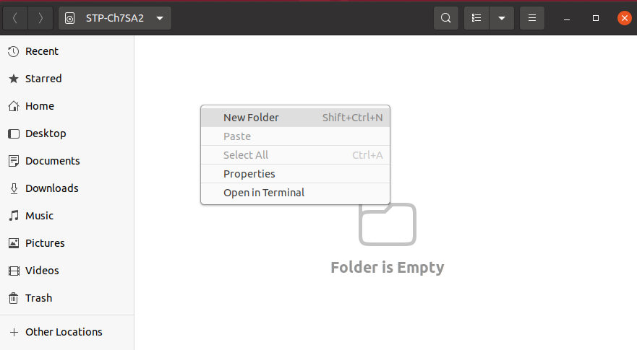
- Open a terminal window, type mount, and press enter. The last entry displayed should be the disk you just formatted, with information about where it is mounted and the file system.
- Insert a screenshot showing the disk that was just mounted.
- To unmount the disk, type umount /dev/sdc and press enter. The disk is no longer mounted. (You can run mount again or look in the Disks utility to verify that the disk is no longer mounted.)
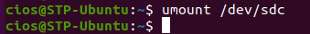
- Close all windows and shut down the Ubuntu VM.

Resources
https://linuxconfig.org/how-fstab-works-introduction-to-the-etc-fstab-file-on-linux

